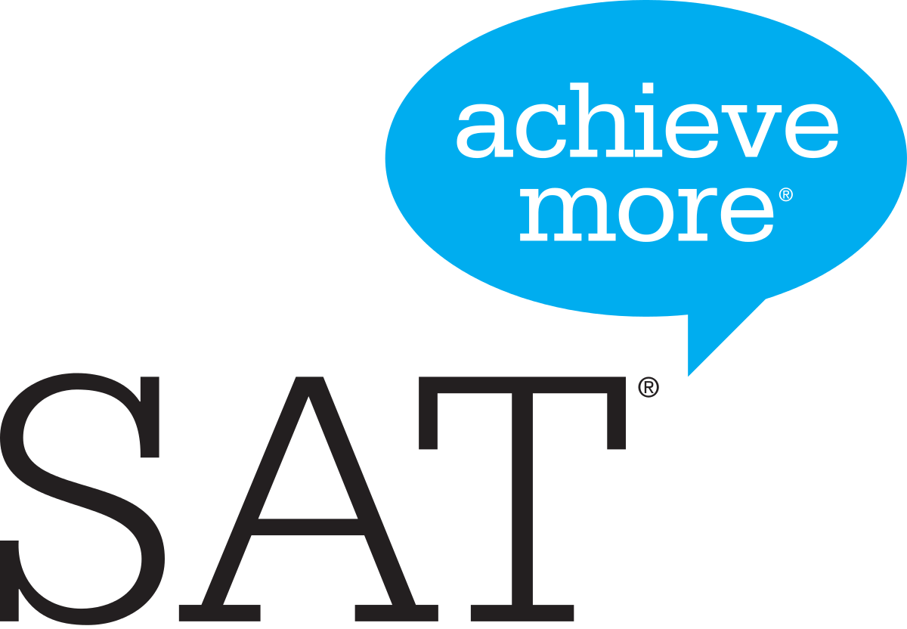 School Day-Spring 2023

  - Take an SAT in school @ PVHS
We are offering our JUNIORS the opportunity to take an SAT in school, on our campus on
Wed., April 12 @ 8:00 am
SAT School Day gives students the opportunity to take the SAT at their own school on a weekday with:
- Less stress and fatigue: Students test in a place they know- better rested and prepared.
- Convenient logistics: You don’t have to worry about locating or getting to the test site.
- No weekend conflicts: School day testing won’t disrupt weekend plans or family time.

Registration for this in-school exam will be handled by the PVHS Counseling Office (not online). Payment is due by March 8. The cost of the exam is $60 or $8 for students on the free/reduced lunch program. Interested students should come to the Counseling Office to register.

Questions? Contact Mrs. Youngberg at dyoungberg@pval.org
or call the HS Counseling Office at 716-988-3276 ext. 4334

